Take it to the Max
The most immersive Sennheiser Soundbar experience gets even better with a massive, free update
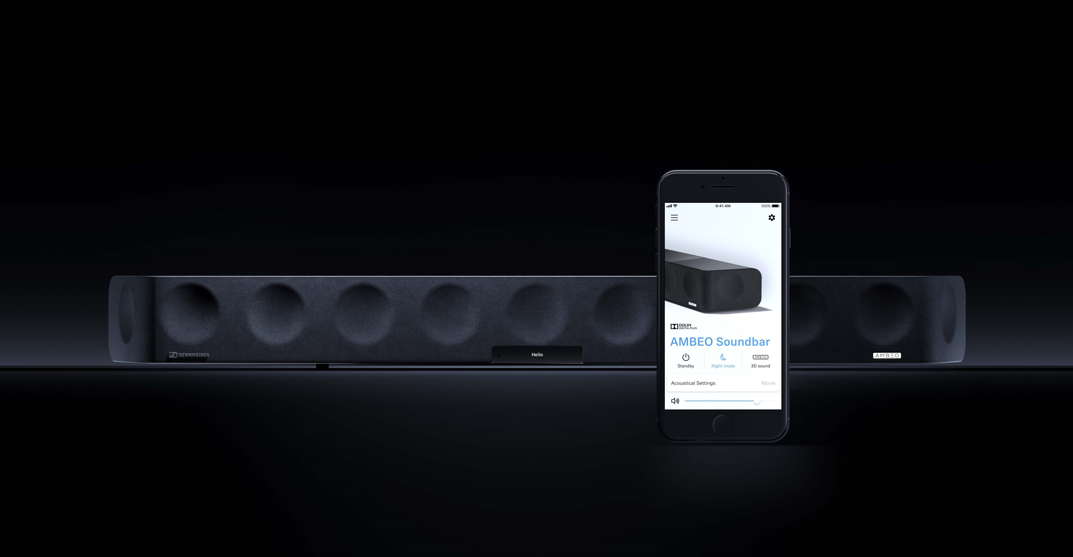

Marlow, United Kingdom – August 21, 2025 – The Sennheiser brand today announces a significant firmware upgrade for the award-winning AMBEO Soundbar | Max. The updated soundbar, using AMBEO | OS2, delivers new features including heightened immersion, enhanced dialogue clarity, and expanded lossless audio music support. This update marks the most substantial advancement since the product’s original launch. With AMBEO | OS2, ‘Max’ owners will enjoy:
- Customisable Immersion – adjustable volume levels for side, top, and centre channel speaker virtualisation, tailoring the immersive 3D experience to personal preferences and to the needs of individual content
- Lossless audio – Extended high-resolution lossless audio performance: native Dolby Atmos Music (via Tidal) is now joined by support for up to 24-bit / 96 kHz audio through Google Cast for Audio, and up to 24-bit / 192 kHz via Tidal Connect
- Voice Enhancement Mode – ensures dialogue remains clear and intelligible, even when sound effects or music dominate the mix in films, shows, and sports
“With AMBEO | OS2, we’re boosting the impressive capabilities of our flagship soundbar even further with high-performance features for music lovers and movie buffs just like us,” said Guy Gampell, Senior Product Manager for AMBEO Soundbars “Whether they’re enjoying a blockbuster film or high-fidelity music, ‘Max’ customers new and old can fill their homes with jaw-dropping sound controlled by the smartphone already in their pocket.”
Availability
AMBEO | OS2 is a free update for all AMBEO Soundbar | Max owners and can be applied using the original Smart Control App (iOS, Android) or over a USB drive from sennheiser-hearing.com.

About the Sennheiser brand
We live and breathe audio. We are driven by the passion to create audio solutions that make a difference. Building the future of audio and bringing remarkable sound experiences to our customers – this is what the Sennheiser brand has represented for more than 75 years. While professional audio solutions such as microphones, meeting solutions, streaming technologies and monitoring systems are part of the business of Sennheiser electronic GmbH & Co. KG, the business with consumer devices such as headphones, soundbars and speech-enhanced hearables became part of the Sonova Holding AG group of companies in 2022, who have licensed the Sennheiser trademark for this purpose.

www.sennheiser.com
www.sennheiser-hearing.com

About Sonova Consumer Hearing
Sonova Consumer Hearing offers premium headphones and hearables – primarily in the true wireless segment – as well as audiophile headphones, hearing solutions and soundbars under the Sennheiser brand. The business is part of the Sonova Group, a global leader in innovative hearing care solutions with headquarters in Switzerland and more than 17,000 employees worldwide.

Press contact
Sonova Consumer Hearing GmbH
Kate Smart
PR & Influencer Manager EMEA
T +44 7909 729925
kate.smart@sonova.com

